Design document
(for Add on’s in AP/ET)

Table of contents

Design document 1
1 About this Document 3
1.1 Change History 3
1.2 Related Documents 3
2 Introduction 4
2.1 Document Purpose 4
2.2 Components to Be Developed 4
2.3 ERD Diagram 9
2.4 Objects / Fields 10
2.5 Validation Rules 11
2.6 Page Layout 11
2.7 Record Types 11
2.8 Visual force pages 11
2.9 Apex Classes 11
2.10 Apex Triggers 11
2.11 Workflows 11
2.12 Email Alerts 11
2.13 Custom Settings 11
2.14 Batch Process 11

About this Document

Change History
Version No. | Date | Nature of Amendment | Affected Pages/Sections
1.0 | 11/23/2013 | Intial Doc Creation

Related Documents
Ref | Title | Author | Issue / Date

Introduction

Document Purpose
The purpose of this document is to list down the functionalities and the effective changes that have been done till date in the design for including Additional Sections in Action Plan.

Components to Be Developed
The details on the components are listed in the below sections below
Solution Blueprint:
The solution consists of following flow and details –

At Action Plan Level
- A New Section “Other Products” will be introduced in Action Plan.
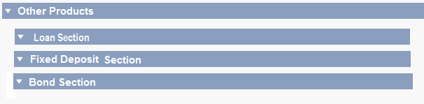
- In Loan section,
- Records will be provided an option to Open Execution Tracker for them with a picklist as (Yes/No).
- Email notification needs to go out to ET owner when ET is opened. PO needs to get email and SMS.
- As soon as action Plan is created or updated, its related RPP is calculated based on the Amount entered.
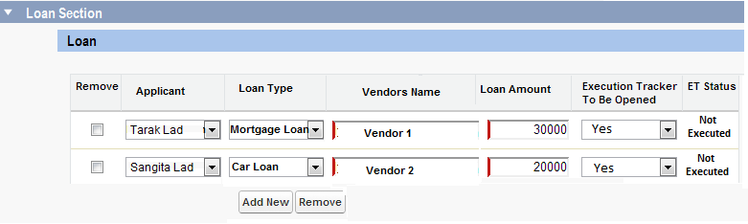
- In Fixed Deposit section,
- Records will be provided an option to Open Execution Tracker for them with a picklist as (Yes/No).
- Email notification needs to go out to ET owner when ET is opened. PO needs to get email and SMS.
- Scheme Name will come with dropdown picklist from Product Master depending on the Selected company Name.
- As soon as action Plan is created or updated, its related RPP is calculated based on the Amount entered.
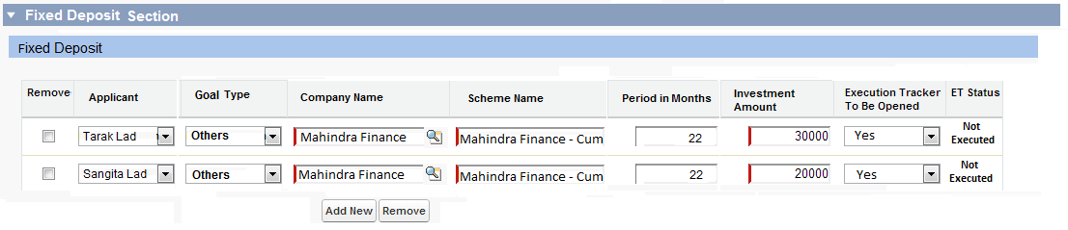
- In Bonds section,
- Records will be provided an option to Open Execution Tracker for them with a picklist as (Yes/No).
- Email notification needs to go out to ET owner when ET is opened. PO needs to get email and SMS.
- Category will come with dropdown picklist from Product Master depending on the Selected company Name.
- As soon as action Plan is created or updated, its related RPP is calculated based on the Amount entered.

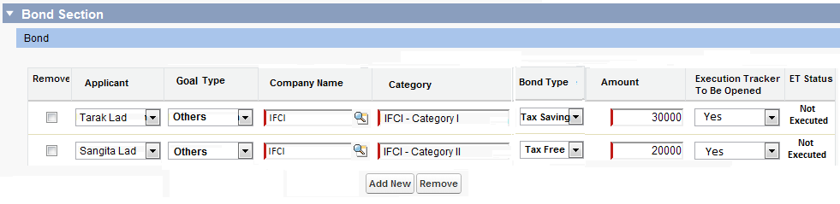
At Execution Tracker Level

- If Loan section’s ET to be opened field is marked as yes, then following process is executed.
- As soon as ET record is created or updated, its related RPP is created or updated.
- Once ET record is created, on Click of Open Link, MET Screen will be displayed.
- MET member needs to fill Agreed Amount and assign it to Operation Team Members.
- Email notification to Ops team member. PO also intimated via email and SMS.
- If Operation Team gets all the required information, they will manually close that record.
- There is no partial Execution concept for this section.

- MET Loan Window
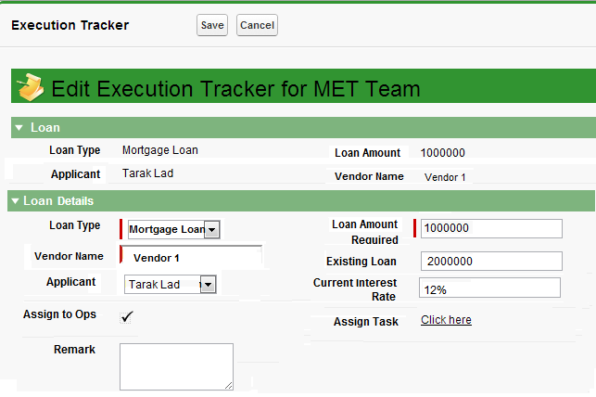

- Operations Team Loan Window
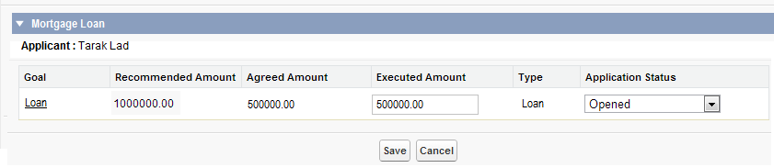

- Operations Team Detail Loan Window
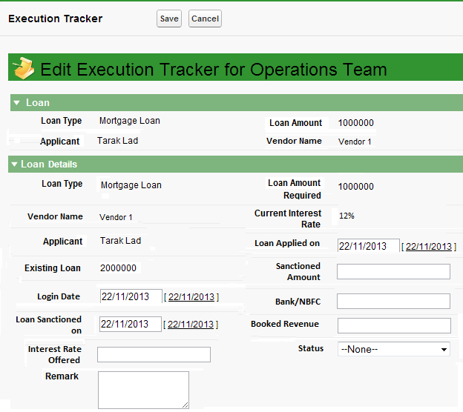

- If Fixed Deposit section’s ET to be opened field is marked as yes, then following process is executed.
- As soon as ET record is created or updated, its related RPP is created or updated.
- Once ET record is created, on Click of Open Link, MET Screen will be displayed.
- MET member needs to fill Agreed Amount and assign it to Operation Team Members.
- Email notification to Ops team member. PO also intimated via email and SMS.
- If Operation Team gets all the required information, they will manually close that record.
- There is no partial Execution concept for this section.
- MET Fixed Deposit Window
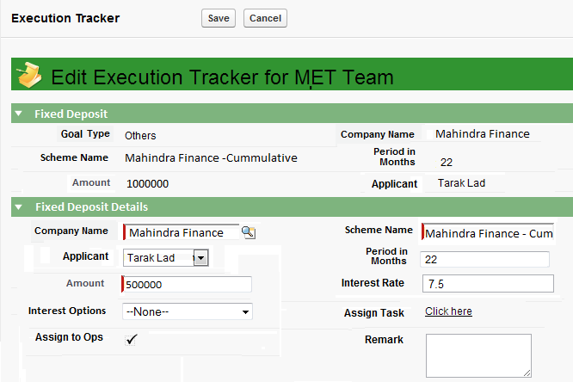

- Operations Team Fixed Deposit Window
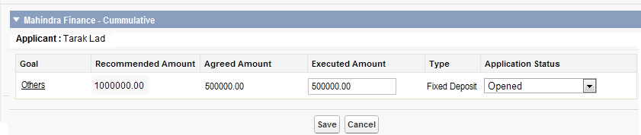
- Operations Team Detail Fixed Deposit Window
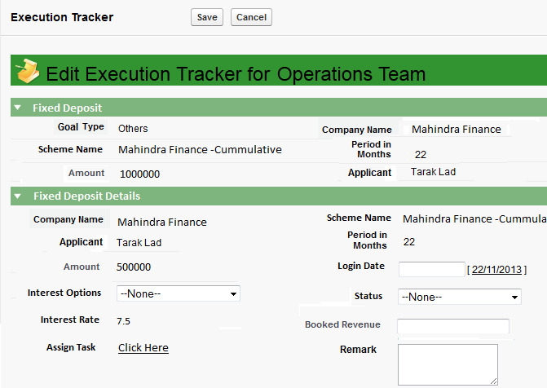
- If Bonds section’s ET to be opened field is marked as yes, then following process is executed.
- As soon as ET record is created or updated, its related RPP is created or updated.
- Once ET record is created, on Click of Open Link, MET Screen will be displayed.
- MET member needs to fill Agreed Amount and assign it to Operation Team Members.
- Email notification to Ops team member. PO also intimated via email and SMS.
- If Operation Team gets all the required information, they will manually close that record.
- There is no partial Execution concept for this section.
- MET Bond Window
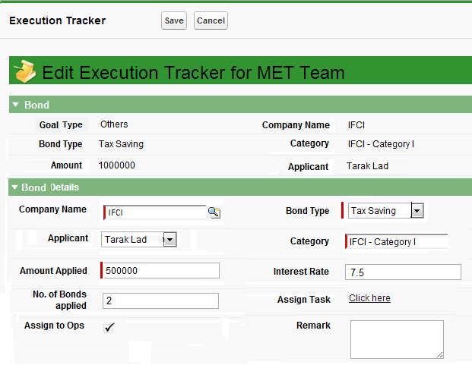
- Operations Team Bond Window
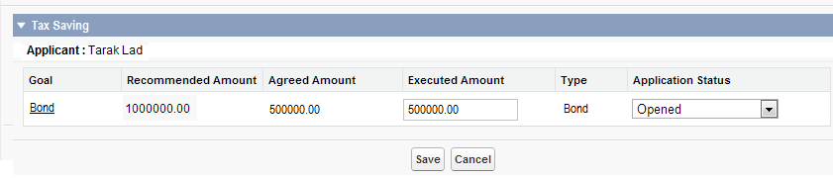
- Operations Team Detail Bond Window
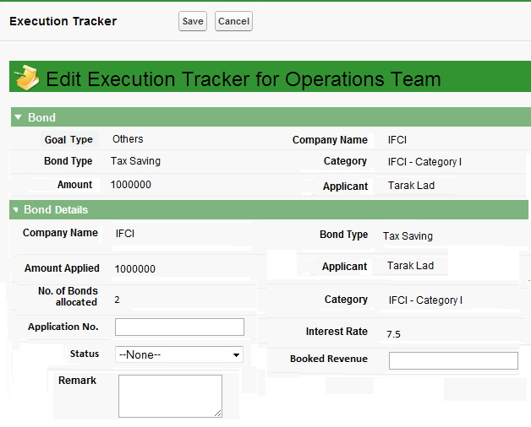

At RPP Level
- When RPP is created or Updated during Action Plan, then it Expected Upfront and Trail Commission is calculated.
- Once the ET record is closed by operations team, its related RPP is calculated with Actual Upfront and Trail Commission
- Whenever ET is assigned or updated, email and sms needs to go to PO and email notification to current ET action owner.

ERD Diagram
Execution Tracker (Custom Object)
- Approve Action Plan (Action Plan Look Up)
- Entity Name (Account Look up)
- Interest Option
- Interest Rate
-Company Name(Product Manufacturer Look Up)
-Period in Months(Number)
-Application Status (picklist)
-Agreed Amount
-Executed Amount
-Suggested Amount
-Booked Revenue
-Remarks
-Login Date
-Add on Status (picklist - Pending / Sanctioned / rejected / disbursed)
-No of Bonds Applied
-Application No.
-Existing Loan
- Loan applied on
- Loan sanctioned on
- Bank / NBFC

Approve Action Plan (Custom Object)
- Account (Look up)
- Loan Type (Text)
- Scheme Name (Text)
- Bond Type(Text)
- isAddOnExecutionTracker(checkbox)
- Goal Type (Dynamic picklist along with Others Option)
- Period in Months (Number)
- Company Name (Product Manufacturer LookUp)
- Series (Picklist values – I,II,III)
- Amount

Product Manufacturer (Custom Object)
- Manufacturer Name (Text)
- Short Code (Text)

Product (Custom Object)
- Product Name (Text)
- Product Manufacturer (Look Up)
- Product Type (Text)
- Asset Class(Picklist)
-Investment Type(Picklist)
Commission (Custom Object)
- Product (LookUp)
- Upfront Commision (Text)
- Trail Commision (Text)

Objects / Fields

Object Name: Approve Action Plan
API Name: Approve_Action_Plan__c

Field Name | API Name | Field Type | Fields Present
Account | Account__c | Lookup(Account) | Yes
Loan Type | Loan_Type__c | Text(200) | No
Scheme Name | Scheme_Name__c | Text(200) | Yes
Bond Type | Bond_Type__c | Text(200) | No
isAddOnExecutionTracker | isAddOnExecutionTracker__c | Checkbox | No
Goal Type | Goal_Type__c | Text(200) | No
Peroid in Months | Period_in_Months_c | Number(15, 0) | No
Company Name | Company_Name__c | Look Up (Product Manufacturer) | No
Series | Series__c | Picklist (I,II,III) | No
Amount | Amount__c | Number(15, 0) | Yes

Object Name: Product Master
API Name: Product_Master__c

Field Name | API Name | Field Type | Fields Present
Asset Class | Asset_Class__C | Picklist | No
Investment Type | Investment_Type__c | Picklist | NO

Object Name: Execution Tracker
API Name: Execution_Tracker__c

Field Name | API Name | Field Type | Fields Present
Approve Action Plan | Approve_Action_Plan__c | Look Up(Approve Action Plan) | Yes
Entity Name | Entity_Name__c | Look Up(Account) | Yes
Interest Option | Interest_Option__c | Picklist | No
Interest Rate | Interest_Rate__c | Decimal | No
Company Name | Company_Name__c | Look Up(Product Manufacturer) | No
Period in Months | Period_in_Months_c | Number(15, 0) | No
Application Status | Application_Status__c | Picklist | Yes
Agreed Amount | Agreed_Amount__c | Number(16, 2) | Yes
Executed Amount | Executed_Amount __c | Number(16, 2) | Yes
Suggested Amount | Suggested_Amount__c | Number(16, 2) | Yes
Booked Revenue | Booked_Revenue__c | Currency(16, 2) | Yes
Remarks | Remarks__c | Long Text Area(32000) | Yes
Login Date | Login_Date__c | Date | Yes
Add on Status | Add_on_Status__c | Picklist (Pending / Sanctioned / rejected / disbursed) | No
No of Bonds Applied | No_of_Bonds_Applied__c | Integer | No
Application No | Application_No__c | Number(15, 0) | Yes
Existing Loan | Existing_Loan__c | Number(16, 2) | No
Loan applied on | Loan_Applied_on | Date | No
Loan sanctioned on | Loan_Sanctioned_on | Date | No
Bank / NBFC | Bank_NBFC_Name__c | Text(255) | Yes

Validation Rules
None

Page Layout
None

Record Types
None

Visual force pages
Need to Create 3 different Screens for Loan, Fixed Deposit and Bonds considering MET and Operations Section.

Apex Classes
Need to Create 3 different Screens related Controller for Loan, Fixed Deposit and Bonds considering MET and Operations Section.

Apex Triggers

Trigger | Action | Parent | Details
ActionPlan Trigger (After Insert,After Update) | Modification | - | RPP related changes
ExecutionTracker Trigger (After Insert,After update) | Modification | - | RPP related changes

Workflows
None

Email Alerts
Yes, whenever ET is opened or updated and action allocated to next member in process i.e Met and Ops accordingly.
Also, PO is intimated via email and SMS.

Custom Settings
None

Batch Process
None

